**Project Documentation**

for the

**Sorrento by the Sea Website**

Version 1.0

October 2020

## Client requirements

**Sequenced schedule**

Sorrento by the Sea website is scheduled to complete within four weeks. All breakdown tasks are planned and displayed in the following project plan.

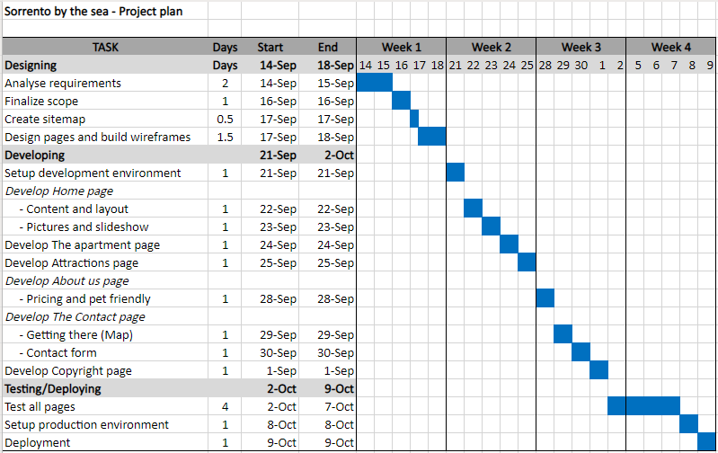

**Sitemap**

Sorrento by the Sea website contains five (6) main pages, including Home, The apartment, Attractions, About us, Contact, and Copyright pages.

Home page (index.html) contains the company information and testimonials. It also shows images that unique attractions of the area, such as the calm front beach on Port Phillip Bay and the wilder surfing beaches on the Bass Strait side, coastal walks, swimming with dolphins and fishing.

The apartment page (apartment.html) contains the information about the apartments and their facilities. The page shows the images of the interior of the apartments, surrounding environment, and nearby facilities.

Attractions page (attraction.html) contains the information about the highlights of local area, such as wineries and restaurants, golf, Peninsula hot springs, Queenscliff-Sorrento ferry, walking tracks, arts and culture, shopping escapades, and water sports.

About us page (about.html) contains the pricing and pet friendly policy. This page provides a link [BOOK NOW] for the customers to access the contact page, which allows the customers to send an enquiry regarding booking, as well as to calculate total price for a specific period.

Contact page (contact.html) contains the contact details, including contact number and address. There is a map on the page, displaying the location of Sorrento by the Sea. Customers can send an enquiry to Sorrento by the Sea’s administrator by submitting the form on the page. Additionally, the customers also can get the total price of a holiday period (three months in advance) by specifying their holiday period and clicking on [Calculate price] button on the page.

Copyright page (copyright.html) contains all image attributions. Links to all the attribution owners are provided to the customers to refer to. The Copyright page is displayed in a new window when the copyright link is clicked from the other 5 main pages.

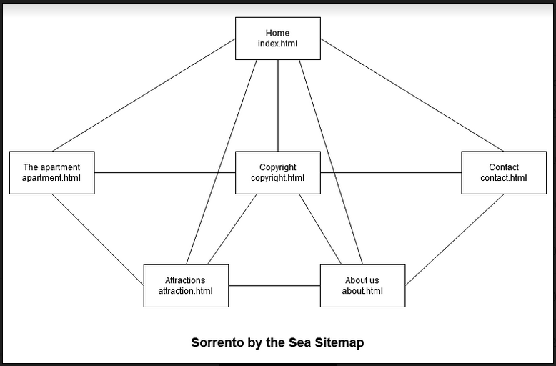

**Wireframes**

The structure of the Home and Contact pages are shown in the following images.

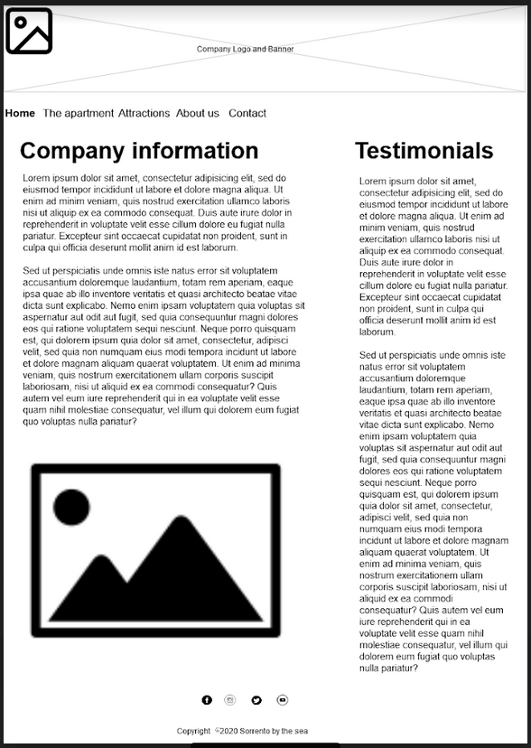

*Home page*

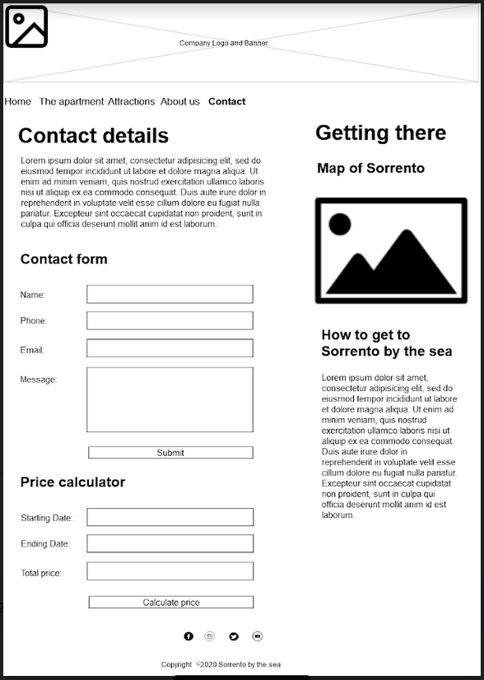

*Contact page*

**Testing plan**

The following testing approaches will be conducted on Sorrento by the Sea website.

1. ***Functionality***

|  |  |  |  |  |
| --- | --- | --- | --- | --- |
| Test scenario ID | All links | | Test case ID | Links-1F |
| Test case description | All links on all pages must work correctly. | | Test priority | High |
| Action/Inputs | | Expected output | Actual output | Test result |
| Launch website  SorrentoByTheSea/index.html | | Home page |  |  |
| Click [Home] on the navigation bar | | Home page |  |  |
| Click [The apartment] on the navigation bar | | The apartment page |  |  |
| Click [Attractions] on the navigation bar | | Attractions page |  |  |
| Click [About us] on the navigation bar | | About us page |  |  |
| Click [Contact] on the navigation bar | | Contact page |  |  |
| Click [BOOK NOW] on About us page | | Contact page |  |  |
| Click logo image at the top of each page | | Home page |  |  |
| Click [Copyright © 2020] on the footer of each page | | Copyright page in a new window |  |  |
| Click [sallysetsforth] on the Copyright page | | Sally Cummings page on flickr.com website is displayed in a new window. |  |  |
| Click [Graeme Bunton] on the Copyright page | | Graeme Bunton page on flickr.com website is displayed in a new window. |  |  |
| Click [Looking Glass] on the Copyright page | | Fernando de Sousa page on flickr.com website is displayed in a new window. |  |  |
| Click [louisa_catlover] on the Copyright page | | Louisa Billeter page on flickr.com website is displayed in a new window. |  |  |
| Click [outbj] on the Copyright page | | Outbj page on flickr.com website is displayed in a new window. |  |  |
| Click [craig siczak] on the Copyright page | | Craig Siczak page on flickr.com website is displayed in a new window. |  |  |
| Click [https://www.flickr.com] on the Copyright page | | flickr.com website is displayed in a new window. |  |  |
| Click [Creative commons CC BY-NC-SA 2.0] on the Copyright page | | Cc creative commons website is displayed in a new window. |  |  |
| Click [Creative commons CC BY-NC-SA 2.0] on the Copyright page | | Cc creative commons website is displayed in a new window. |  |  |
| Click Facebook icon on the footer of each page | | Facebook website opens in a new window. |  |  |
| Click Instagram icon on the footer of each page | | Instagram website opens in a new window. |  |  |
| Click Twitter icon on the footer of each page | | Twitter website opens in a new window. |  |  |
| Click YouTube icon on the footer of each page | | YouTube website opens in a new window. |  |  |

|  |  |  |  |  |
| --- | --- | --- | --- | --- |
| Test scenario ID | Image thumbnail on Home page | | Test case ID | Image-1F |
| Test case description | The images on the Home page are clickable and displayed in thumbnails. | | Test priority | Medium |
| Action/Inputs | | Expected output | Actual output | Test result |
| Click [Home] on the navigation bar | | Images on the Home page are loaded and clickable |  |  |
| Click on an image on the thumbnail | | The selected thumbnail displays on the large image section |  |  |
| Click on the arrow on the large image | | The image changes to the next image |  |  |

|  |  |  |  |  |
| --- | --- | --- | --- | --- |
| Test scenario ID | Sorrento map | | Test case ID | Map-1F |
| Test case description | Map of Sorrento by the Sea must load correctly when the Contact page is load. | | Test priority | High |
| Action/Inputs | | Expected output | Actual output | Test result |
| Click [Contact] on the navigation bar | | Contact page is loaded with a Google Map containing the address of Sorrento at the centre of the map |  |  |
| Click on zoom in icon on the map | | The map is enlarged |  |  |
| Click on zoom out icon on the map | | The map is dwindled |  |  |

1. ***Compatibility***

|  |  |  |  |  |
| --- | --- | --- | --- | --- |
| Test scenario ID | Browser compatibility | | Test case ID | Browser-1C |
| Test case description | Text, images, and layout work across all the following browsers (Google Chrome, Microsoft Edge, and Safari) | | Test priority | High |
| Checklist | | Google Chrome | Microsoft Edge | Safari |
| Page layout | |  |  |  |
| All images and alignment | |  |  |  |
| Banner | |  |  |  |
| Navigation bar | |  |  |  |
| Two columns display | |  |  |  |
| Footer section | |  |  |  |
| Images display | |  |  |  |
| Map displays (Contact page) | |  |  |  |

|  |  |  |  |
| --- | --- | --- | --- |
| Test scenario ID | Device compatibility | Test case ID | Device-1C |
| Test case description | Text, images, and layout work across all the following devices (iOS, Android) | Test priority | High |
| Checklist | | iOS | Android |
| Page layout | |  |  |
| All images and alignment | |  |  |
| Banner | |  |  |
| Navigation bar | |  |  |
| One column display | |  |  |
| Footer section | |  |  |
| Images display | |  |  |
| Map displays (Contact page) | |  |  |

1. ***Usability –*** This test will be carried out by the users.

|  |  |  |  |
| --- | --- | --- | --- |
| Test scenario ID | Content check | Test case ID | Content-1U |
| Test case description | The content on all pages must not have any misspelling words or grammatical errors.  The images are displayed on the right page.  Styles and colours are as described in the technical specifications. | Test priority | Low |
| Checklist | | | Pass/Fail |
| Home page | | |  |
| The apartment page | | |  |
| Attractions page | | |  |
| About us page | | |  |
| Contact page | | |  |
| Copyright page | | |  |

1. ***Website validation***

|  |  |  |  |
| --- | --- | --- | --- |
| Test scenario ID | Code validation | Test case ID | Validation-1V |
| Test case description | HTML and CSS code of all pages are validated using a validator from w3.org. https://validator.w3.org/ | Test priority | Medium |
| Checklist | | | Pass/Fail |
| index.html (Home page) | | |  |
| apartment.html (The apartment page) | | |  |
| attraction.html (Attractions page) | | |  |
| about.html (About us page) | | |  |
| contact.html (Contact page) | | |  |
| copyright.html (Copyright page) | | |  |
| mainstyle.css | | |  |
| home_slideshow.css | | |  |

**Mark-up language**

HyperText Markup Language (HTML) will be used for creating the website of this project because HTML can create electronic documents or web pages and display them on the World Wide Web. HTML can create the structure of the webpage, format text and images to display in browsers. It works with Cascading Style Sheets (CSS) to make it easy to define presentation or styling of the website. It also works with JavaScript which can be used for all the input validation. HTML is simple and easy to create and maintain because of its meaningful tags and attributes that allow for better semantics, as well as the separation of styling and structure of each page.

## Test and validate the website

1. **Functionality**

|  |  |  |  |  |  |  |  |  |  |
| --- | --- | --- | --- | --- | --- | --- | --- | --- | --- |
| Test scenario ID | | All links | | | | Test case ID | | Links-1F | |
| Test case description | | All links on all pages must work correctly. | | | | Test priority | | High | |
| Action/Inputs | | | | Expected output | | Actual output | | Test result | |
| Launch website  SorrentoByTheSea/index.html | | | | Home page | | Home page | | Pass | |
|  | | | | | | | | | | |
| Click [Home] on the navigation bar | | | | Home page | | Home page | | Pass | |
| Before    After clicking [Home] on the navigation bar | | | | | | | | | | |
| Click [The apartment] on the navigation bar | | | | The apartment page | | The apartment page | | Pass | |
|  | | | | | | | | | | |
| Click [Attractions] on the navigation bar | | | | Attractions page | | Attractions page | | Pass | |
|  | | | | | | | | | |
| Click [About us] on the navigation bar | | | | About us page | | About us page | | Pass | |
|  | | | | | | | | | |
| Click [Contact] on the navigation bar | | | | Contact page | | Contact page | | Pass | |
|  | | | | | | | | | |
| Click [BOOK NOW] on About us page | | | | Contact page | | Contact page | | Pass | |
| Before    After clicking [BOOK NOW] on the About us page | | | | | | | | | |
| Click logo image at the top of each page | | | | Home page | | Home page | | Pass | |
| Click on the logo on the Contact page Return to Home page  Click on the logo on the About us page Return to Home page  Click on the logo on the Attractions page Return to Home page  Click on the logo on The apartment page Return to Home page    Click on the logo on the Home page Stay on to Home page | | | | | | | | | |
| Click [Copyright © 2020] on the footer of each page | | | | Copyright page in a new window | | Copyright page in a new window | | Pass | |
| Click [Copyright © 2020]    Copyright page in a new window | | | | | | | | | |
| Click [sallysetsforth] on the Copyright page | | | | Sally Cummings page on flickr.com website is displayed in a new window. | | Sally Cummings on flickr.com website is displayed in a new window. | | Pass | |
|  | | | | | | | | | |
| Click [Graeme Bunton] on the Copyright page | | | | Graeme Bunton page on flickr.com website is displayed in a new window. | | Graeme Bunton page on flickr.com website is displayed in a new window. | | Pass | |
| Click [Looking Glass] on the Copyright page | | | | Fernando de Sousa page on flickr.com website is displayed in a new window. | | Fernando de Sousa page on flickr.com website is displayed in a new window. | | Pass | |
| Click [louisa_catlover] on the Copyright page | | | | Louisa Billeter page on flickr.com website is displayed in a new window. | | Louisa Billeter page on flickr.com website is displayed in a new window. | | Pass | |
| Click [outbj] on the Copyright page | | | | Outbj page on flickr.com website is displayed in a new window. | | Outbj page on flickr.com website is displayed in a new window. | | Pass | |
| Click [craig siczak] on the Copyright page | | | | Craig Siczak page on flickr.com website is displayed in a new window. | | Craig Siczak page on flickr.com website is displayed in a new window. | | Pass | |
| Click [https://www.flickr.com] on the Copyright page | | | | flickr.com website is displayed in a new window. | | Flickr.com website is displayed in a new window | | Pass | |
| Click [Creative commons CC BY-NC-SA 2.0] on the Copyright page | | | | Cc creative commons website is displayed in a new window. | | Cc creative commons website is displayed in a new window. | | Pass | |
| Click [Creative commons CC BY-NC-SA 2.0] on the Copyright page | | | | Cc creative commons website is displayed in a new window. | | Cc creative commons website is displayed in a new window. | | Pass | |
| Click Facebook icon on the footer of each page | | | | Facebook website opens in a new window. | | Facebook website opens in a new window. | | Pass | |
| Click Instagram icon on the footer of each page | | | | Instagram website opens in a new window. | | Instagram website opens in a new window. | | Pass | |
| Click Twitter icon on the footer of each page | | | | Twitter website opens in a new window. | | Twitter website opens in a new window. | | Pass | |
| Click YouTube icon on the footer of each page | | | | YouTube website opens in a new window. | | YouTube website opens in a new window. | | Pass | |
| Test scenario ID | Image thumbnail on Home page | | | | Test case ID | | Image-1F | |
| Test case description | The images on the Home page are clickable and displayed in thumbnails. | | | | Test priority | | Medium | |
| Action/Inputs | | | Expected output | | Actual output | | Test result | |
| Click [Home] on the navigation bar | | | Images on the Home page are loaded and clickable | | Images on the Home page are loaded and clickable | | Pass | |
|  | | | | | | | | |
| Click on an image on the thumbnail | | | The selected thumbnail displays on the large image section | | The selected thumbnail displays on the large image section | | Pass | |
| The second image on the thumbnail is clicked    The third image on the thumbnail is clicked    The first image on the thumbnail is clicked | | | | | | | | |
| Click on the arrow on the large image | | | The image changes to the next image | | The image changes to the next image | | Pass | |
| The arrow on the right of the large image is clicked    The arrow on the left of the large image is clicked | | | | | | | | |

|  |  |  |  |  |
| --- | --- | --- | --- | --- |
| Test scenario ID | Sorrento map | | Test case ID | Map-1F |
| Test case description | Map of Sorrento by the Sea must load correctly when the Contact page is load. | | Test priority | High |
| Action/Inputs | | Expected output | Actual output | Test result |
| Click [Contact] on the navigation bar | | Contact page is loaded with a Google Map containing the address of Sorrento at the centre of the map | Contact page is loaded with a Google Map containing the address of Sorrento at the centre of the map | Pass |
|  | | | | |
| Click on zoom in icon on the map | | The map is enlarged | The map is enlarged | Pass |
|  | | | | |
| Click on zoom out icon on the map | | The map is dwindled | The map is dwindled | Pass |
|  | | | | |

1. **Compatibility**

|  |  |  |  |  |
| --- | --- | --- | --- | --- |
| Test scenario ID | Browser compatibility | | Test case ID | Browser-1C |
| Test case description | Text, images, layout and JavaScript functions work across all the following browsers (Google Chrome, Microsoft Edge, and Safari) | | Test priority | High |
| Checklist | | Google Chrome | Microsoft Edge | Safari |
| Page layout | | Checkmark PNG, Checkmark Transparent Background - FreeIconsPNG | Checkmark PNG, Checkmark Transparent Background - FreeIconsPNG | Checkmark PNG, Checkmark Transparent Background - FreeIconsPNG |
| Google Chrome  Microsoft Edge  Safari | | | | |
| All images and alignment | | Checkmark PNG, Checkmark Transparent Background - FreeIconsPNG | Checkmark PNG, Checkmark Transparent Background - FreeIconsPNG | Checkmark PNG, Checkmark Transparent Background - FreeIconsPNG |
| Google Chrome  Microsoft Edge  Safari | | | | |
| Banner | | Checkmark PNG, Checkmark Transparent Background - FreeIconsPNG | Checkmark PNG, Checkmark Transparent Background - FreeIconsPNG | Checkmark PNG, Checkmark Transparent Background - FreeIconsPNG |
| Navigation bar | | Checkmark PNG, Checkmark Transparent Background - FreeIconsPNG | Checkmark PNG, Checkmark Transparent Background - FreeIconsPNG | Checkmark PNG, Checkmark Transparent Background - FreeIconsPNG |
| Two columns display | | Checkmark PNG, Checkmark Transparent Background - FreeIconsPNG | Checkmark PNG, Checkmark Transparent Background - FreeIconsPNG | Checkmark PNG, Checkmark Transparent Background - FreeIconsPNG |
| Footer section | | Checkmark PNG, Checkmark Transparent Background - FreeIconsPNG | Checkmark PNG, Checkmark Transparent Background - FreeIconsPNG | Checkmark PNG, Checkmark Transparent Background - FreeIconsPNG |
| Images display | | Checkmark PNG, Checkmark Transparent Background - FreeIconsPNG | Checkmark PNG, Checkmark Transparent Background - FreeIconsPNG | Checkmark PNG, Checkmark Transparent Background - FreeIconsPNG |
| Map displays (Contact page) | | Checkmark PNG, Checkmark Transparent Background - FreeIconsPNG | Checkmark PNG, Checkmark Transparent Background - FreeIconsPNG | Checkmark PNG, Checkmark Transparent Background - FreeIconsPNG |
| Safari  Google Chrome  Microsoft Edge | | | | |

|  |  |  |  |
| --- | --- | --- | --- |
| Test scenario ID | Device compatibility | Test case ID | Device-1C |
| Test case description | Text, images, and layout display across all the following devices (iOS, Android) | Test priority | High |
| Checklist | | iOS | Android |
| Page layout | | Delete Cross Black - Free vector graphic on Pixabay | Delete Cross Black - Free vector graphic on Pixabay |
|  | | | |
| All images and alignment | | Checkmark PNG, Checkmark Transparent Background - FreeIconsPNG | Checkmark PNG, Checkmark Transparent Background - FreeIconsPNG |
| Banner | | Checkmark PNG, Checkmark Transparent Background - FreeIconsPNG | Checkmark PNG, Checkmark Transparent Background - FreeIconsPNG |
| Navigation bar | | Delete Cross Black - Free vector graphic on Pixabay | Delete Cross Black - Free vector graphic on Pixabay |
| One column display | | Delete Cross Black - Free vector graphic on Pixabay | Delete Cross Black - Free vector graphic on Pixabay |
| Footer section | | Delete Cross Black - Free vector graphic on Pixabay | Delete Cross Black - Free vector graphic on Pixabay |
| Images display | | Delete Cross Black - Free vector graphic on Pixabay | Delete Cross Black - Free vector graphic on Pixabay |
| Map displays (Contact page) | | Checkmark PNG, Checkmark Transparent Background - FreeIconsPNG | Checkmark PNG, Checkmark Transparent Background - FreeIconsPNG |

1. **Usability –** This test will be carried out by the users.

|  |  |  |  |
| --- | --- | --- | --- |
| Test scenario ID | Content check | Test case ID | Content-1U |
| Test case description | The content on all pages must not have any misspelling words or grammatical errors.  The images are displayed on the right page.  Styles and colours are as described in the technical specifications. | Test priority | Low |
| Checklist | | | Pass/Fail |
| Home page | | | Pass |
| The apartment page | | | Pass |
| Attractions page | | | Pass |
| About us page | | | Fail |
| Content in the Pricing section is confusing.  It needs rearrangement.  (Refer to re-testing section for the amendment). | | | |
| Contact page | | | Fail |
| **Information and Booking** should be a heading.  ‘Sorrento by the Sea Apartment – Luxury Self Contained Apartment’ should locate above the address.  The last paragraph under ‘How to get to Sorrento by the Sea’ that reads “If you are a foot passenger we are happy to meet you at the Sorrento ferry **at**. Just phone us on 0435 123 456 as you arrive.” needs change to  “If you are a foot passenger**,** we are happy to meet you at the Sorrento ferry. Just phone us on 0435 123 456 as you arrive.”  Explanation:  Add a comma ‘,’ after the phrase ‘foot passenger’.  Remove the word ‘at’ after the phrase ‘at the Sorrento ferry’ | | | |
| Copyright page | | | Pass |

1. **Website validation**

|  |  |  |  |
| --- | --- | --- | --- |
| Test scenario ID | Code validation | Test case ID | Validation-1V |
| Test case description | HTML and CSS code of all pages are validated using a validator from w3.org. https://validator.w3.org/ | Test priority | Medium |
| Checklist | | | Pass/Fail |
| index.html (Home page) | | | Pass |
|  | | | |
| apartment.html (The apartment page) | | | Pass |
|  | | | |
| attraction.html (Attractions page) | | | Pass |
|  | | | |
| about.html (About us page) | | | Pass |
|  | | | |
| contact.html (Contact page) | | | Pass |
|  | | | |
| copyright.html | | | Pass |
|  | | | |
| mainstyle.css | | | Pass |
|  | | | |
| home_slideshow.css | | | Pass |
|  | | | |

The display on an iPhone 6/7/8 using Google Toggle device to emulate the screenshot of the website.

**Problem 1 - Compatibility:** The whole page appears on the screen which will make the elements on the page appeared small and cannot be seen clearly by the users, using such a small device comparing to the browsers on a PC.

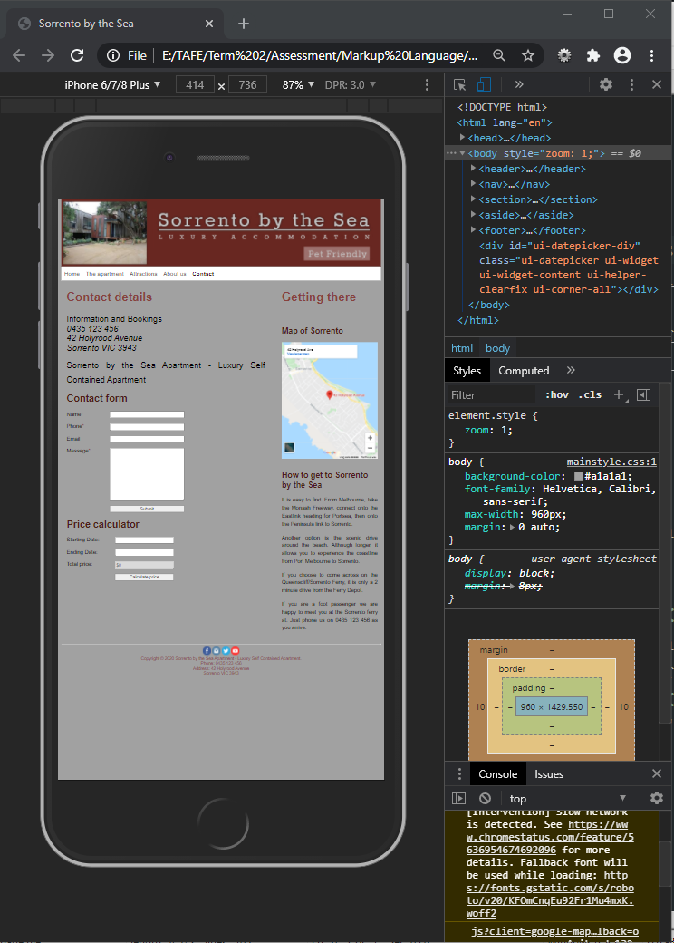

**Solution:** Add <meta name="viewport" content="width-device-width, initial-scale=1.0"> in the <header></header> tag of each page.

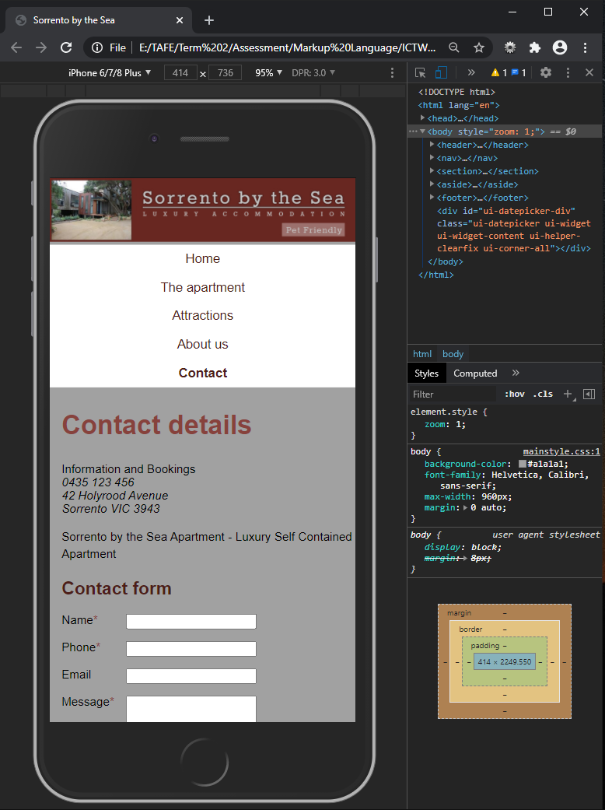

By adding the meta tag viewport element, the website will become responsive when it is displayed on different devices, such as a mobile phone, which has a smaller screen than on a computer screen.

**Problem:** Font sizes of the text on the page are too big comparing with the company logo on top of the page.

**Solution:** Change the h1, h2, and body font-size to be relatively small comparing with the size of the screen in CSS file under the [@media screen and (max-width: 600px)] section.

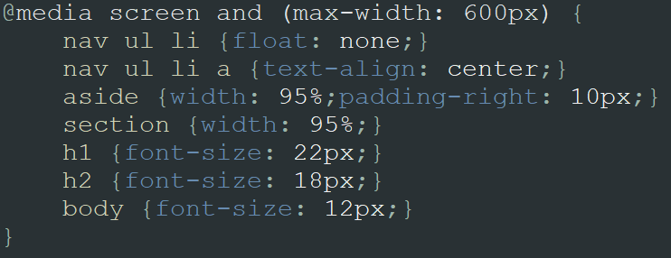

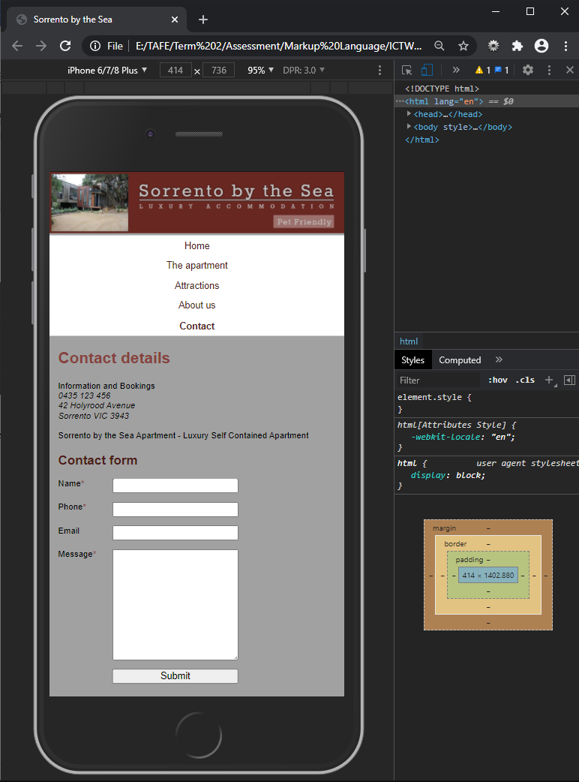

**Re-testing:** Compatibility approach is re-tested and the code of each page is re-validated.

|  |  |  |  |
| --- | --- | --- | --- |
| Test scenario ID | Device compatibility | Test case ID | Device-1C |
| Test case description | Text, images, and layout display across all the following devices (iOS, Android) | Test priority | High |
| Checklist | | iOS | Android |
| Page layout | | Checkmark PNG, Checkmark Transparent Background - FreeIconsPNG | Checkmark PNG, Checkmark Transparent Background - FreeIconsPNG |
|  | | | |
| All images and alignment | | Checkmark PNG, Checkmark Transparent Background - FreeIconsPNG | Checkmark PNG, Checkmark Transparent Background - FreeIconsPNG |
|  | | | |
| Banner | | Checkmark PNG, Checkmark Transparent Background - FreeIconsPNG | Checkmark PNG, Checkmark Transparent Background - FreeIconsPNG |
| Navigation bar | | Checkmark PNG, Checkmark Transparent Background - FreeIconsPNG | Checkmark PNG, Checkmark Transparent Background - FreeIconsPNG |
| One column display | | Checkmark PNG, Checkmark Transparent Background - FreeIconsPNG | Checkmark PNG, Checkmark Transparent Background - FreeIconsPNG |
| Footer section | | Checkmark PNG, Checkmark Transparent Background - FreeIconsPNG | Checkmark PNG, Checkmark Transparent Background - FreeIconsPNG |
|  | | | |
| Images display | | Checkmark PNG, Checkmark Transparent Background - FreeIconsPNG | Checkmark PNG, Checkmark Transparent Background - FreeIconsPNG |
| Map displays (Contact page) | | Checkmark PNG, Checkmark Transparent Background - FreeIconsPNG | Checkmark PNG, Checkmark Transparent Background - FreeIconsPNG |
|  | | | |

|  |  |  |  |  |
| --- | --- | --- | --- | --- |
| Test scenario ID | Browser compatibility | | Test case ID | Browser-1C |
| Test case description | Text, images, layout and JavaScript functions work across all the following browsers (Google Chrome, Microsoft Edge, and Safari) | | Test priority | High |
| Checklist | | Google Chrome | Microsoft Edge | Safari |
| Page layout | | Checkmark PNG, Checkmark Transparent Background - FreeIconsPNG | Checkmark PNG, Checkmark Transparent Background - FreeIconsPNG | Checkmark PNG, Checkmark Transparent Background - FreeIconsPNG |
| Google Chrome  Microsoft Edge  Safari | | | | |
| All images and alignment | | Checkmark PNG, Checkmark Transparent Background - FreeIconsPNG | Checkmark PNG, Checkmark Transparent Background - FreeIconsPNG | Checkmark PNG, Checkmark Transparent Background - FreeIconsPNG |
| Google Chrome  Microsoft Edge  Safari | | | | |
| Banner | | Checkmark PNG, Checkmark Transparent Background - FreeIconsPNG | Checkmark PNG, Checkmark Transparent Background - FreeIconsPNG | Checkmark PNG, Checkmark Transparent Background - FreeIconsPNG |
| Navigation bar | | Checkmark PNG, Checkmark Transparent Background - FreeIconsPNG | Checkmark PNG, Checkmark Transparent Background - FreeIconsPNG | Checkmark PNG, Checkmark Transparent Background - FreeIconsPNG |
| Two columns display | | Checkmark PNG, Checkmark Transparent Background - FreeIconsPNG | Checkmark PNG, Checkmark Transparent Background - FreeIconsPNG | Checkmark PNG, Checkmark Transparent Background - FreeIconsPNG |
| Footer section | | Checkmark PNG, Checkmark Transparent Background - FreeIconsPNG | Checkmark PNG, Checkmark Transparent Background - FreeIconsPNG | Checkmark PNG, Checkmark Transparent Background - FreeIconsPNG |
| Images display | | Checkmark PNG, Checkmark Transparent Background - FreeIconsPNG | Checkmark PNG, Checkmark Transparent Background - FreeIconsPNG | Checkmark PNG, Checkmark Transparent Background - FreeIconsPNG |
| Map displays (Contact page) | | Checkmark PNG, Checkmark Transparent Background - FreeIconsPNG | Checkmark PNG, Checkmark Transparent Background - FreeIconsPNG | Checkmark PNG, Checkmark Transparent Background - FreeIconsPNG |
| Safari  Google Chrome  Microsoft Edge | | | | |

|  |  |  |  |
| --- | --- | --- | --- |
| Test scenario ID | Code validation | Test case ID | Validation-1V |
| Test case description | HTML and CSS code of all pages are validated using a validator from w3.org. https://validator.w3.org/ | Test priority | Medium |
| Checklist | | | Pass/Fail |
| index.html (Home page) | | | Pass |
|  | | | |
| apartment.html (The apartment page) | | | Pass |
|  | | | |
| attraction.html (Attractions page) | | | Pass |
|  | | | |
| about.html (About us page) | | | Pass |
|  | | | |
| contact.html (Contact page) | | | Pass |
|  | | | |
| mainstyle.css | | | Pass |
|  | | | |
| home_slideshow.css | | | Pass |
|  | | | |

**Problem 2 – Usability of About us page**:

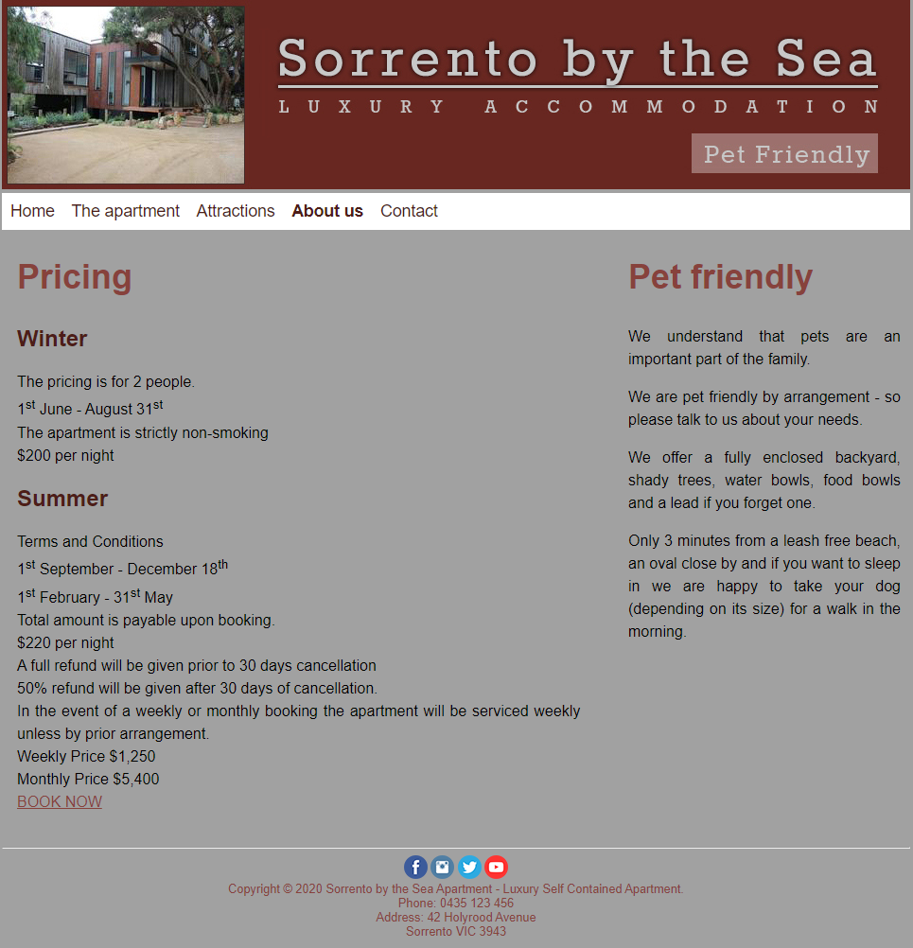

Content in the Pricing section is confusing.

It needs rearrangement.

**Solution:** Rearrange the information under the topic ‘Pricing’ as following:

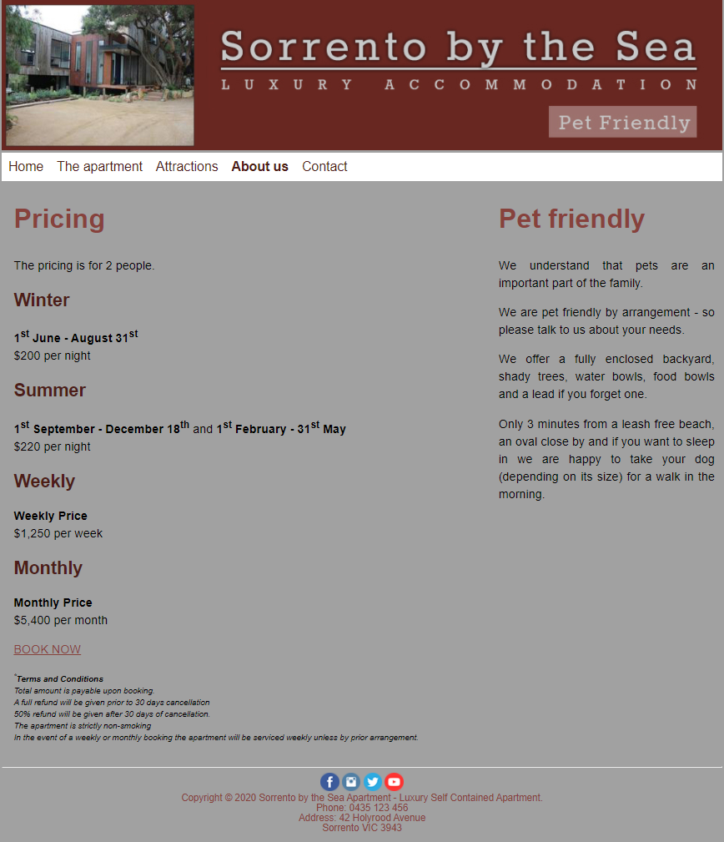

Group pricing into four categories: Winter, Summer, Weekly, and Monthly.

Reduce font size of Term and Condition and make it italic.

**Re-testing**

|  |  |  |  |
| --- | --- | --- | --- |
| Test scenario ID | Content check | Test case ID | Content-1U |
| Test case description | The content on About us must not have any misspelling words or grammatical errors.  Links direct to the right page. | Test priority | Low |
| Checklist | | | Pass/Fail |
| About us page | | | Pass |

|  |  |  |  |
| --- | --- | --- | --- |
| Test scenario ID | Code validation | Test case ID | Validation-1V |
| Test case description | About us HTML page and CSS code are validated using a validator from w3.org. https://validator.w3.org/ | Test priority | Medium |
| Checklist | | | Pass/Fail |
| about.html (About us page) | | | Pass |
|  | | | |
| mainstyle.css | | | Pass |
|  | | | |

**Problem 3 – Usability of Contact page**:

1. The contact details are ambiguous.
2. A comma ‘,’ is missing and there is an extra ‘at’ in the last paragraph.
3. The gap between ‘Getting there’ heading and ‘Map of Sorrento’ heading is too big.

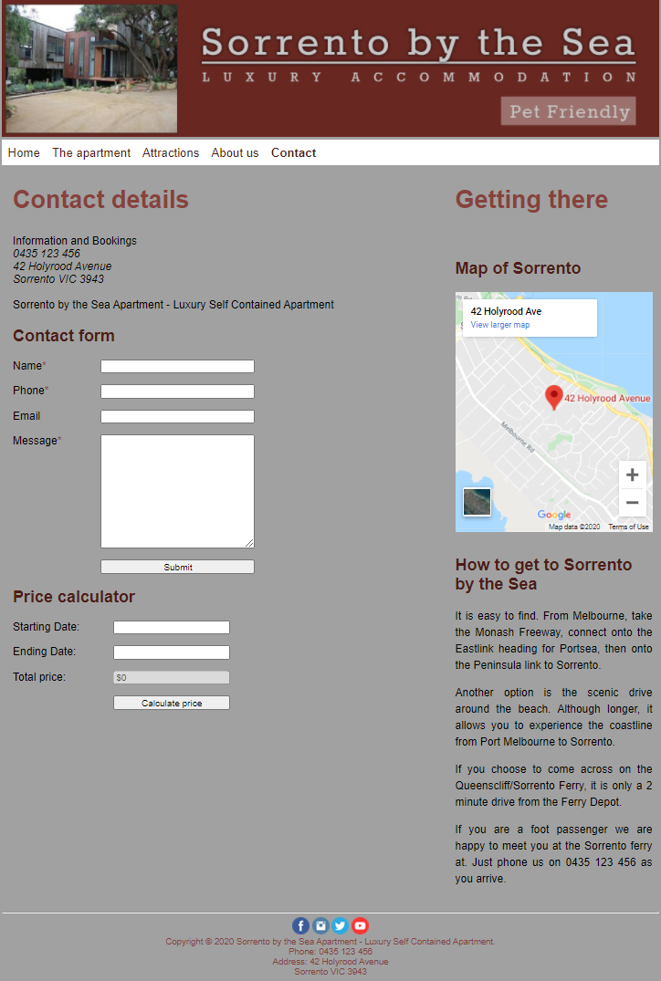

**Solution:**

1. Information and Booking should be a header and the word ‘Phone:’ and ‘Address:’ should be added in front of the company’s phone number and address. The phrase ‘Sorrento by the Sea Apartment – Luxury Self Contained Apartment’ should locate above the address.
2. The last paragraph under ‘How to get to Sorrento by the Sea’ that reads “If you are a foot passenger we are happy to meet you at the Sorrento ferry **at**. Just phone us on 0435 123 456 as you arrive.” needs change to “If you are a foot passenger**,** we are happy to meet you at the Sorrento ferry. Just phone us on 0435 123 456 as you arrive.”
3. Reduce the gap between the two heading.

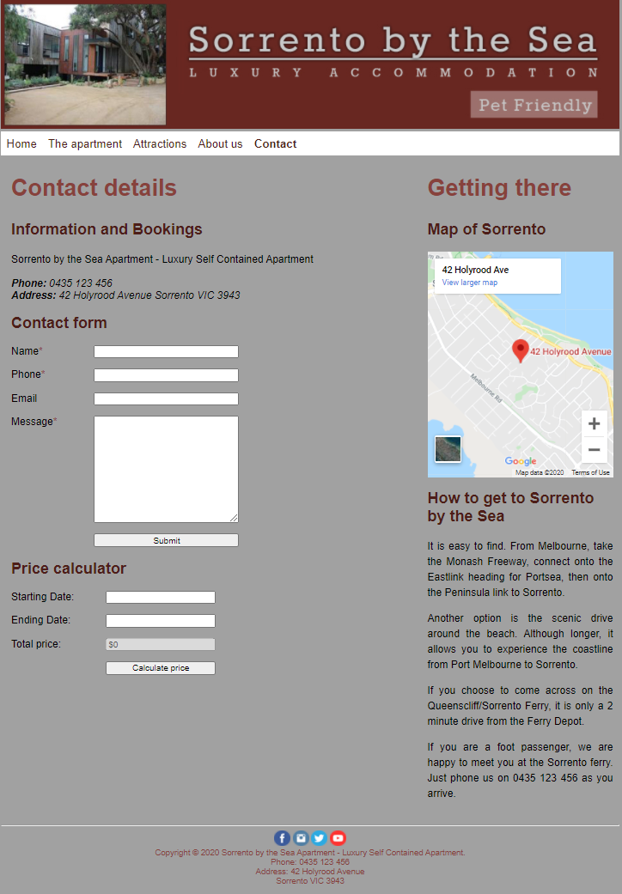

**Re-testing**

|  |  |  |  |
| --- | --- | --- | --- |
| Test scenario ID | Content check | Test case ID | Content-1U |
| Test case description | The content on Contact page must not have any misspelling words or grammatical errors. | Test priority | Low |
| Checklist | | | Pass/Fail |
| Contact page | | | Pass |

|  |  |  |  |
| --- | --- | --- | --- |
| Test scenario ID | Code validation | Test case ID | Validation-1V |
| Test case description | Contact HTML page is validated using a validator from w3.org. https://validator.w3.org/ | Test priority | Medium |
| Checklist | | | Pass/Fail |
| contact.html (Contact page) | | | Pass |
|  | | | |

Explain the testing process and the results, including any outstanding issues and corrective actions.

There are three testing processes for this web project, consisting of the functionality testing, compatibility testing, and usability testing.

**Functionality testing** – All the links on every page and the Contact form are tested.

***Note:*** *Contact form is out of scope of this project.*

*Step 1:* Test all the links on the menu bar of all pages that they link to the right page.

*Step 2:* Test the company logo that it links to the Home page or index.html.

*Step 3:* Check map to ensure that it is loaded properly and is able to zoom in and out.

*Step 4:* Check images on the thumbnail and slideshow to ensure that the selected image is shown as expected.

*Step 5:* Test Copyright © 2020 on the footer of every page to ensure that the Copyright page is opened in a new window.

*Step 6:* Test all the links on the Copyright page to ensure that all the external links are working.

*Step 7:* Validate HTML pages and CSS code to ensure the industry standard is met.

**Compatibility testing** – The website is tested for browser compatibility and device compatibility.

*Step 1:* Download major browsers, like Google Chrome, Microsoft Edge, Safari, etc.

*Step 2:* Open each page on all browsers and check text, images, layouts, and JavaScript functions that hey work across all the browsers.

*Step 3:* Emulate each page on mobile devices emulator and check text images, layouts, and JavaScript functions that they work across devices, like iPhone, Samsung, etc.

**Usability testing** – The content on all pages are correct without any misspelling or grammatical errors. The images are displayed on the right page. Styles and colours are as specified in the project technical specifications.

*Step 1:* Read the content on each page to verify the spelling and grammar.

*Step 2:* Check the styles and colours on each page again the technical specifications.

During the testing process, some outstanding issues are:

* the layout of the pages is not aligned
* HTML syntax error, like missing HTML close tags, misspelling tag names
* CSS syntax error, like missing { or ;, misspelling keywords
* misused of margin and padding properties, which caused unexpected layout of the page

The corrective actions to the outstanding issues are:

* using % or em instead of px when assigning values to properties, such as width: 30%, margin-left: 1em
* validating HTML pages and CSS code at <https://validator.w3.org/> to find out HTML and CSS syntax errors
* drawing CSS box model and finding out the required margin and padding values when facing layout problems
* after fixing the issues, all related pages are required to test again